1 Go into the my-first website folder and open the about-me.html file

It opens in your web browser

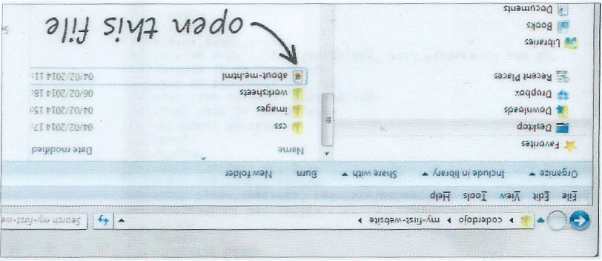

2 Now open the same file in a plain text editor such as Notepad

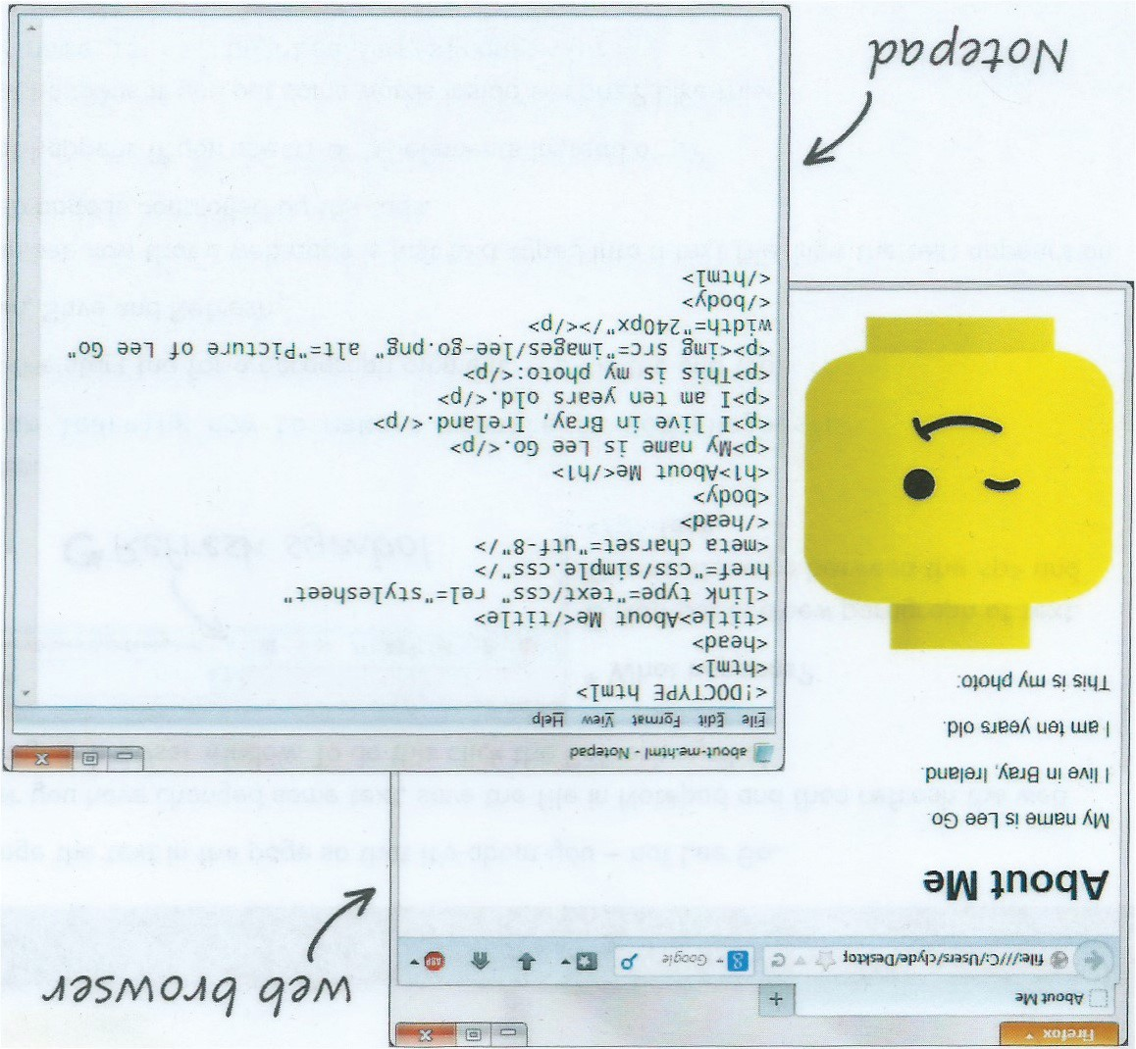

3 Next section with bold text

Sample Text Box – drag this around

4 Next section with bold text